# **FinOps in Multicloud: make tagging and policy your “pre-architecture”**

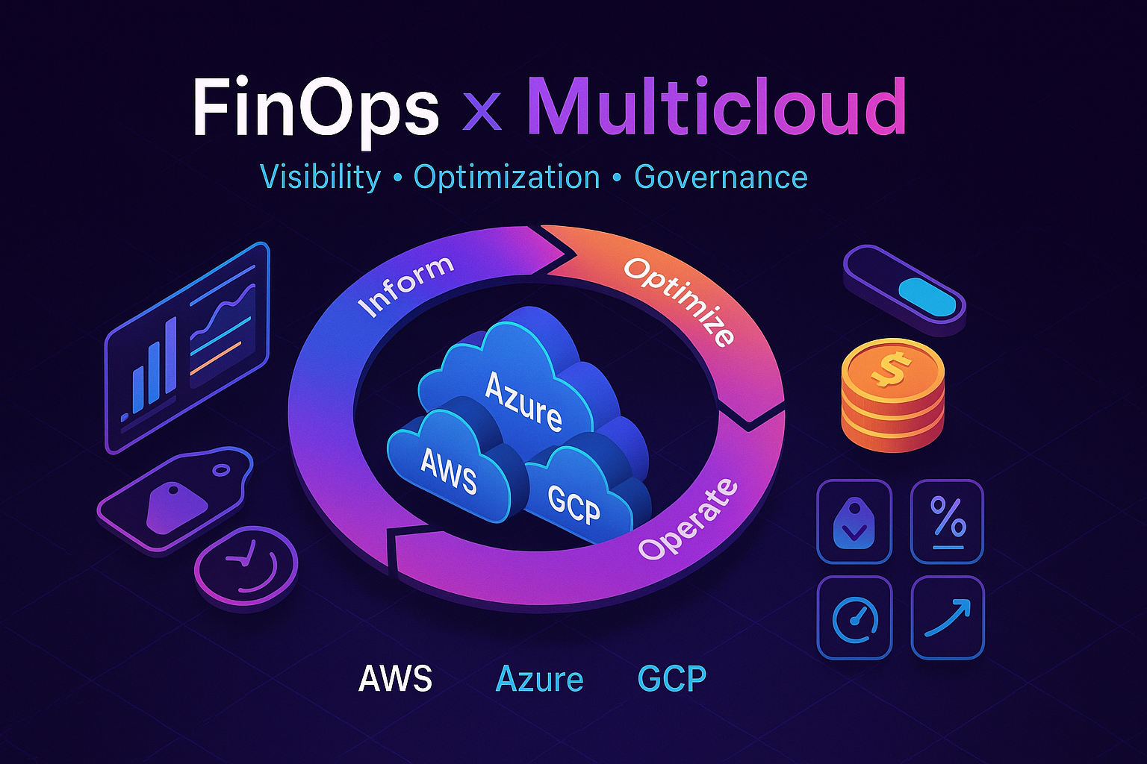

Quarterly review. The CFO asks, “Why did cloud spend jump 18%?”—and the room goes quiet. Screens fill with unlabeled resources, cryptic names, and three clouds’ worth of guesswork. That’s what life without FinOps looks like. Now picture the team that started with pre-architecture: owners, names, and tags are mandatory; policy-as-code enforces them across AWS, Azure, and GCP; dashboards show unit costs (per customer, experiment, or model run); rightsizing and commitments run on autopilot. Their conversation isn’t “why did it spike?”—it’s “what ROI did we deliver and where do we invest next?” FinOps turns cloud from an unexplainable bill into a measurable profit engine. Checkout my new medium article:

**Pre-Architecture** isn’t paperwork; it’s the moment you decide whether cloud will be a cost center or a profit engine. Before the first resource lands, you lock in **who owns what, how it’s named, and how it’s tagged**—and you enforce it with **policy-as-code** across AWS, Azure, and GCP. Do that, and your bills roll up cleanly; skip it, and every executive review turns into guesswork.

Why so strict? Because leaders buy **outcomes**, not EC2 hours or Blob GBs. The only way to answer **“cost per X”** (per customer, per API call, per order, per GB, per inference) is to join **cost lines** with **business metrics**—and **tags are the join keys**. No tags → no join → no “cost per X.” Pre-Architecture sets the rules, policy keeps them honest, and your cross-cloud dashboard makes it visible.

## **1) Why “cost per X” is impossible without tags**

To compute meaningful unit economics you need all three:

* **Cost lines** (AWS CUR, Azure Exports, GCP Billing).
* **Business metrics** (product analytics, telemetry, or your DB).
* **A join key**—that’s your **tags/labels**.  
  + *Think of tags as foreign keys between finance and reality.*
  + **No tags → no join → no “cost per X.”**

## **2) Design tags for cost-per metrics (before you deploy)**

**Name the metric first**, then pick the tag that will serve as the join key:

* TenantId → **cost per customer**
* Feature → **cost per feature/experiment**
* DataTier → **cost per GB tier**
* ModelName / Version → **cost per inference**

**Make tagging mandatory at create-time** (policy-as-code). *No tag, no deploy.* Use **controlled vocabularies** to avoid report explosions.  
 Use a **rollup tag** (e.g., cm-resource-parent) so costs aggregate cleanly under “container” resources.  
 **Avoid secrets/PII** in tags—tags are plain text and widely visible.

## **3) The “cost per” cookbook (multicloud-friendly)**

Each example lists the **metric**, **how to tag**, **formula**, and **what it unlocks**.

1. **Cost per customer (SaaS multi-tenant)**
   * **Tag:** TenantId (or AccountId), Service, Env, Owner
   * **Formula:** sum(cost where TenantId=X and Env='Prod') / active_users_X
   * **Unlocks:** pricing strategy, margin by customer, discount decisions
   * **Note:** use opaque IDs, not PII
2. **Cost per API request**
   * **Tag:** Service, Workload, Env, cm-resource-parent (for rollups)
   * **Formula:** sum(cost for Service='api-gateway') / total_api_requests
   * **Unlocks:** rate-limit economics, cache-vs-compute trade-offs
3. **Cost per order / transaction**
   * **Tag:** Service=checkout, Feature=payments, Env=Prod, CostCenter
   * **Formula:** sum(cost for Feature='payments') / orders_count
   * **Unlocks:** payment-provider ROI, SLO cost curves
4. **Cost per GB stored (tiered storage)**
   * **Tag:** DataTier (Hot/Cool/Archive), DataDomain (Logs/Media/DB), Retention
   * **Formula:** sum(storage_cost where DataTier='Hot') / hot_gb
   * **Unlocks:** auto-tiering policies, retention ROI, “cold data tax” visibility
5. **Cost per build minute (CI/CD)**
   * **Tag:** Pipeline, Repo, Team, Env=CI
   * **Formula:** sum(compute+artifacts cost for Pipeline=P) / build_minutes_P
   * **Unlocks:** flaky test economics, mono vs. polyrepo cost
6. **ML: cost per 1k inferences**
   * **Tag:** ModelName, Version, Env, DataClassification
   * **Formula:** sum(GPU/CPU + egress for Model=Y) / (tokens_or_requests/1000)
   * **Unlocks:** pricing by model tier, rollout gating for expensive versions
7. **Data platform: cost per TB scanned (ETL/queries)**
   * **Tag:** Dataset, Domain (Sales/Marketing), JobId
   * **Formula:** sum(query/compute cost for Dataset=D) / TB_scanned_D
   * **Unlocks:** partitioning/compaction ROI, schema hygiene incentives
8. **Kubernetes: cost per service**
   * **Tag/Label:** app, namespace, team, plus cm-resource-parent=<cluster> on Azure
   * **Formula:** sum(node+storage+LB attributed to app=A) / request_rate_A
   * **Unlocks:** fair showback, HPA/rightsizing business impact

## **4) Pre-Architecture details you enforce from day zero**

### **Naming + tagging policy (the “pre-architecture” step)**

* **Define a naming convention once**, use it everywhere (resource groups, accounts/subscriptions, projects). A well-defined naming and tagging strategy is the foundation of effective Azure governance and security.
* **Publish a tagging standard & dictionary** covering purpose, ownership, environment, cost center, business unit, and data sensitivity.  
  + Treat some as **mandatory** (Owner, Business Unit, Environment/SDLC, Cost Center, optional Financial Owner).
  + Keep others **discretionary** (Compliance, Workload ID, SLA, Backup, Lifespan…) for when you need them.
* **GDPR & privacy:** tags are plain text in reports/APIs—don’t store sensitive values.

### **Azure tagging facts you’ll use a lot**

* Tags apply to **resources, resource groups, and subscriptions**—**not** management groups.
* Tags are **not inherited** by default.
* Limits: **50** tag name–value pairs per resource. Name up to **512** chars (storage accounts: **128**). Value up to **256**.
* Disallowed characters: <, >, %, &, \, ?, /.
* Not all resource types/purchases emit tags into **Cost Analysis**—use the **Tag support** matrix when tags “don’t show up.”

### **AWS tagging facts you’ll use a lot**

* Use **Organizations Tag Policies** to standardize allowed keys/values and casing across accounts; combine with **IAM/SCPs** to **deny creates without required tags**.
* **Retroactive tag backfill:** management accounts can backfill **up to 12 months** of Cost Allocation Tags—perfect when you formalize tags late.

## **5) Enforce it automatically (or it won’t stick)**

### **On Azure**

* Assign **Azure Policy** built-ins:  
  + *Add a tag to resources*
  + *Require a tag on resources*
  + *Inherit a tag from the resource group*
* Use **modify/deny** effects and **remediation** to fix existing resources.

### **On AWS**

* Use **IAM conditions** (aws:RequestTag, aws:TagKeys) to **require** tags at creation.
* Pair **Tag Policies** for consistency with **SCPs** for guardrails.
* Adopt **ABAC** (attribute-based access control) by matching **principal tags** to **resource tags**.

## **6) Bonus for Azure cost clarity: cm-resource-parent**

When there’s a clear parent→child relationship (e.g., **AKS cluster → node pools, VMs, disks**), add cm-resource-parent=<parent resourceId> on the children. Azure Cost Management will roll them up under the parent in the **Resources** view—fewer noisy rows, cleaner totals.

**Rule of thumb:**

* Always grouped by a “container”? → **Use cm-resource-parent.**
* Sometimes grouped / many views? → **Use normal tags.**

## **7) Turn raw cloud bills into one multicloud dashboard**

**Goal:** one place to answer *who built this, where is it, and why does it cost money?*

### **Data pipes (native + low-friction)**

* **AWS → S3 (CUR):** enable the **Cost & Usage Report** to S3, then query with **Athena**.
* **Azure → Blob Storage:** schedule **Cost Management Exports** to an Azure Storage account (CSV/Parquet) or use the **Cost Details API**.
* **GCP → BigQuery:** turn on **Cloud Billing export** to BigQuery.

### **Model (normalize) the data**

* Create a thin, **FOCUS-like** schema with:  
   cloud, billing_account, subscription/account/project, service, sku, resource_id, tags (json), usage, cost, currency, region, date.
* The FinOps Foundation’s **FOCUS** is the emerging standard for cross-cloud normalization.

### **Visualize**

* **Power BI** reads AWS CUR via **Athena** (native connector/ODBC).
* **Looker Studio** reads **BigQuery** directly (for GCP and any normalized warehouse hosted there).

### **Storage-specific drilldowns (S3 + Azure Storage)**

* **AWS S3:** join **CUR (costs)** with **S3 Inventory (objects/prefixes)** in **Athena** to see **cost by bucket/prefix/object patterns**.
* **Azure Blob:** enable **Blob Inventory** (CSV/Parquet) and blend with Azure cost exports to see **cost by container/tier/age**.

## **8) Minimal tag dictionary you can start with today**

| **Tag key** | **Why it matters** |
| --- | --- |
| **Owner** | Who to ping; supports ABAC and accountability. |
| **BusinessUnit** | Roll up spend to your org structure. |
| **Environment** | Prod / Dev / Test / Sandbox—drives policies & risk. |
| **CostCenter** | Finance reconciliation, showback/chargeback. |
| **DataClassification** | Flags regulated/sensitive workloads *(don’t put PII in the tag)*. |

**Tip:** Azure cost tools can group by tag, but some purchases or classic resources won’t carry tags—expect “Untagged/Tags not supported” lines until you clean up.

## **9) Quick wins you’ll actually see on the dashboard**

* **Untagged spend %** and **top untagged resources**—make it a KPI (FinOps “Allocation” capability).
* **Owner heatmap** (Owner × Environment) to find runaway dev/test.
* **Storage aging & tiering** (Blob Inventory + S3 Inventory) to push cold data to cheaper tiers.
* **12-month tag backfill (AWS)** to immediately improve historic reports after you standardize.

## **10) API hooks you’ll reference later**

* **Azure Billing & Cost Management REST APIs** for automated pulls and export management.
* **AWS CUR + Athena** for SQL over cost data (and **S3 Inventory** joins).

## **11) Common pitfalls (and how to dodge them)**

* **“We tagged the RG—why don’t child resources show it?”** Azure tags aren’t inherited; enforce inheritance with **Azure Policy (modify/append)**.
* **“Tags still don’t appear in Azure cost.”** Some services/purchases don’t emit tags; check the **tag support** matrix.
* **“We activated AWS cost tags but can’t see history.”** Use **Cost Allocation Tag Backfill** (up to **12 months**).
* **“Engineers forget tags.”** **Deny** untagged creates (AWS IAM/SCP) and **auto-add** with Azure Policy **modify + remediation**.

## **Conclusion**

Without a tagging strategy, cloud ROI is unknowable. Finance sees providers and SKUs; product sees features and customers. **Tags translate between the two**—they’re the legend on the map, and without them your dashboards *look* right but **lie by omission**. You’ll ship optimizations that *feel* right but don’t move unit economics—because you can’t measure **cost per outcome**.

The market is shifting from “developers & admins” to **FinOps as the final QA**—essential in an era of vibe coding. Every change should pass three gates:

* **Design QA:** Are the **join-key tags** in place to measure outcomes?
* **Policy QA:** Will non-compliant resources be **blocked or remediated** automatically?
* **Economic QA:** Can we compute **cost per X on day one**?

If any answer is “no,” it doesn’t ship. That’s **Pre-Architecture**.  
 **Tag like it’s schema, enforce like it’s security, measure like it’s revenue.** When every feature ships with an explainable price tag, you’re not just in the cloud—you’re **running a business in the cloud**.